# Smart Contract Deployment on Public Network

K20-1052 Hassan Ali

K20-0244 Munir Abbasi

K20-1045 Mustafa Zahid

1. Connected to MetaMask RSK Testnet.

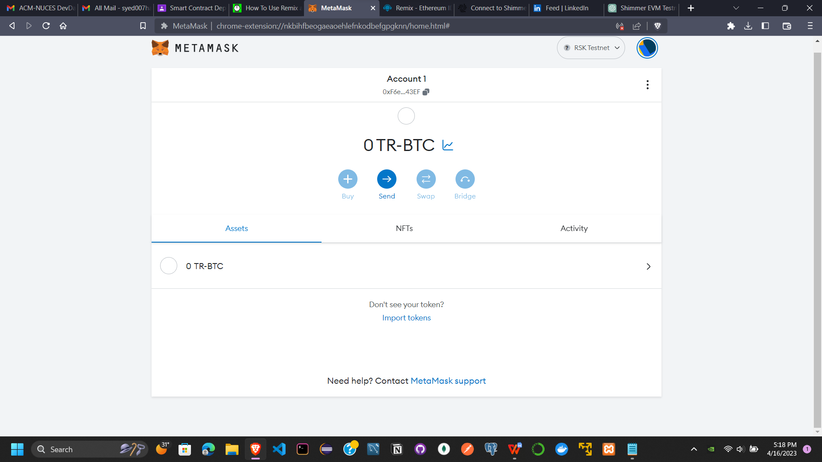

1. Sending some amount (RBTC) to your address

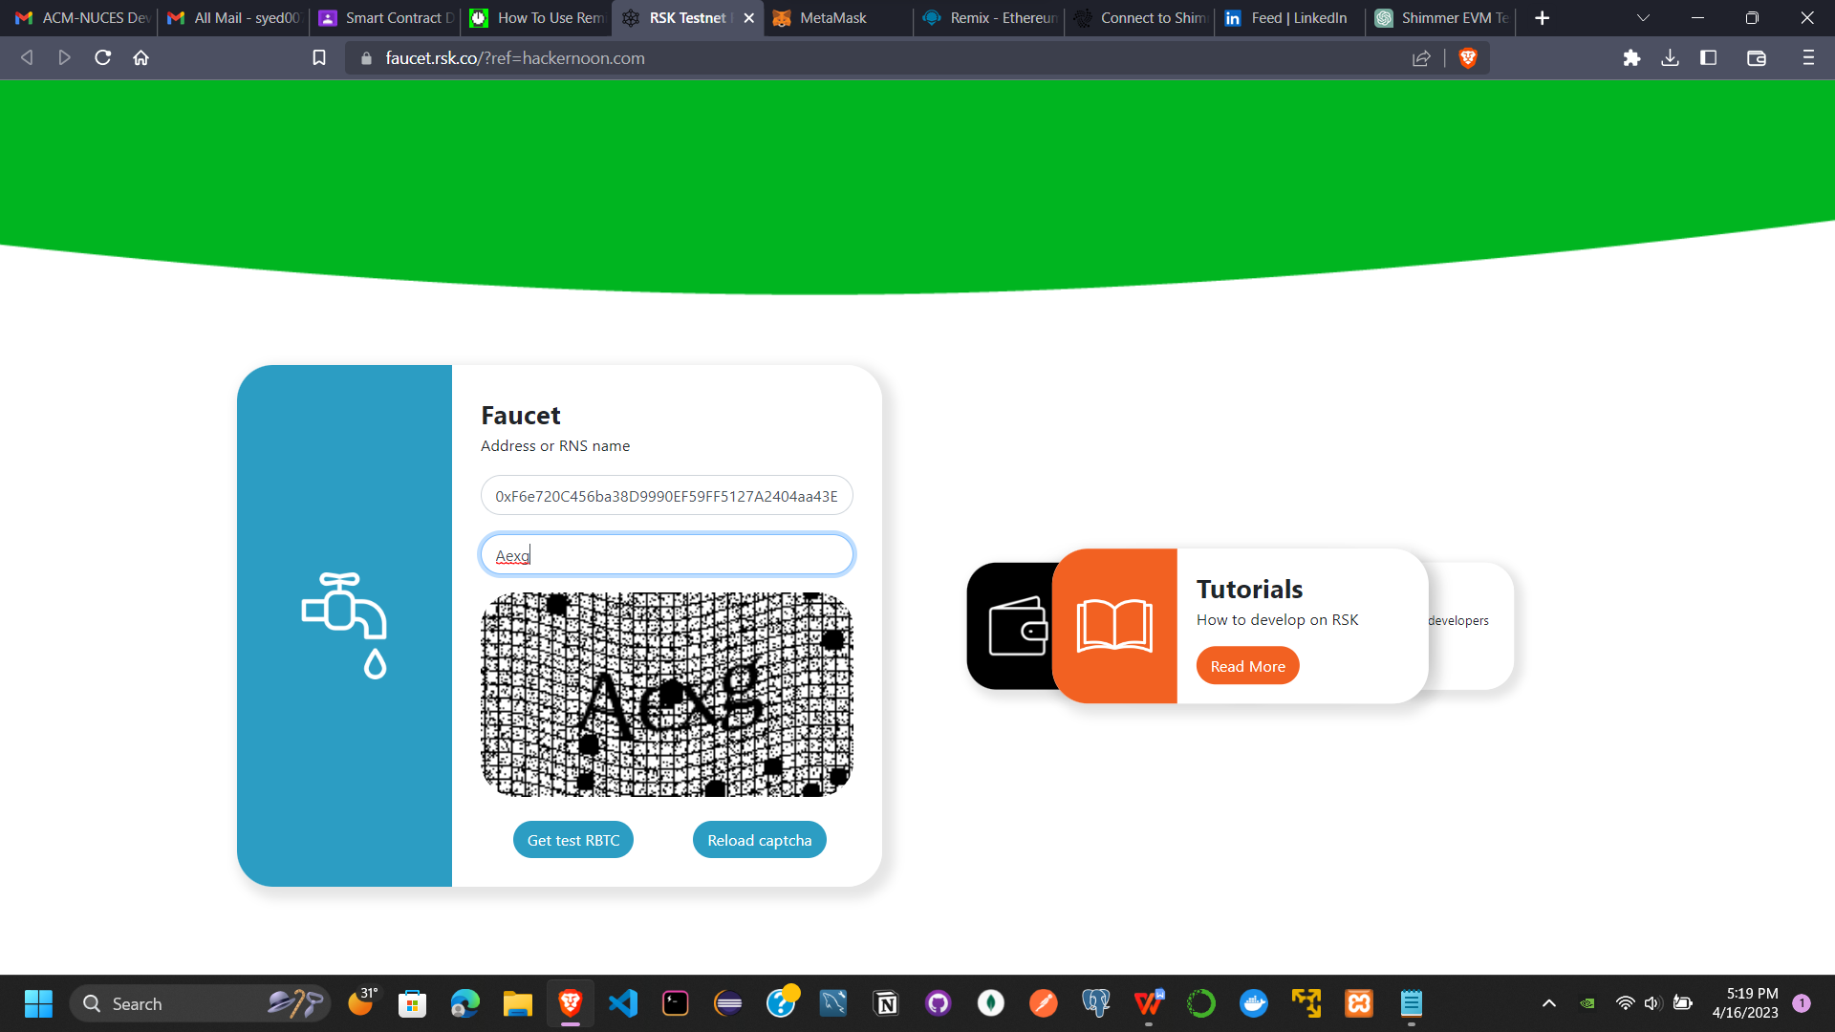

1. Amout received.

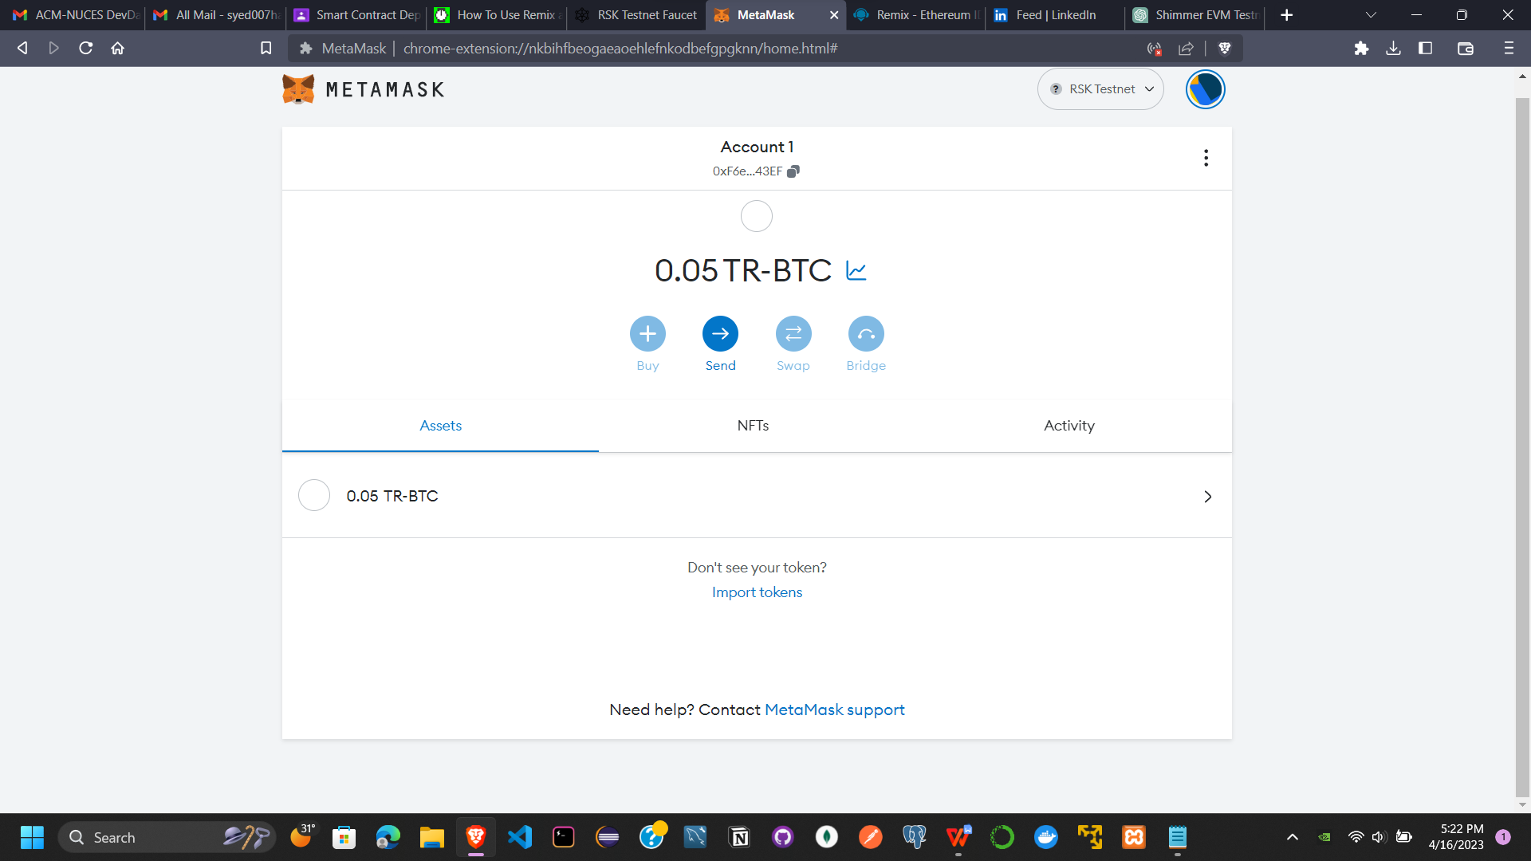

1. Changed the enviroment to MetaMask and linked the Remix with your MetaMask account having 0.05 RBTC.

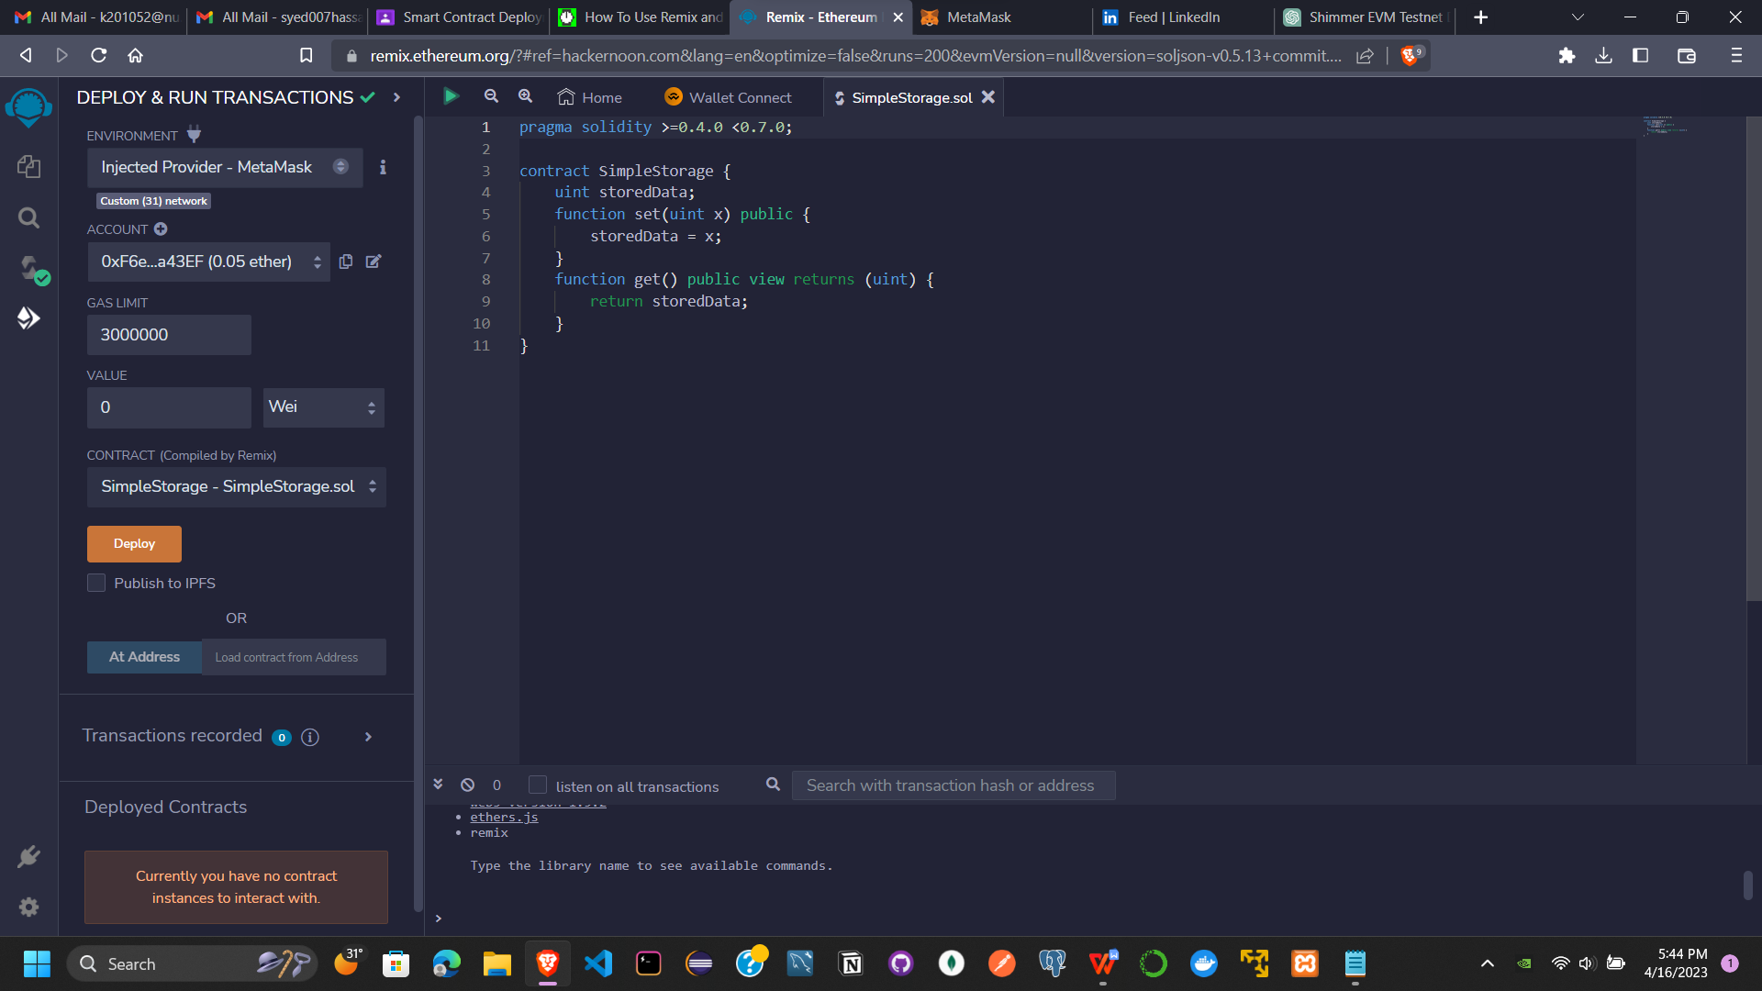

1. Created a simple storage file.

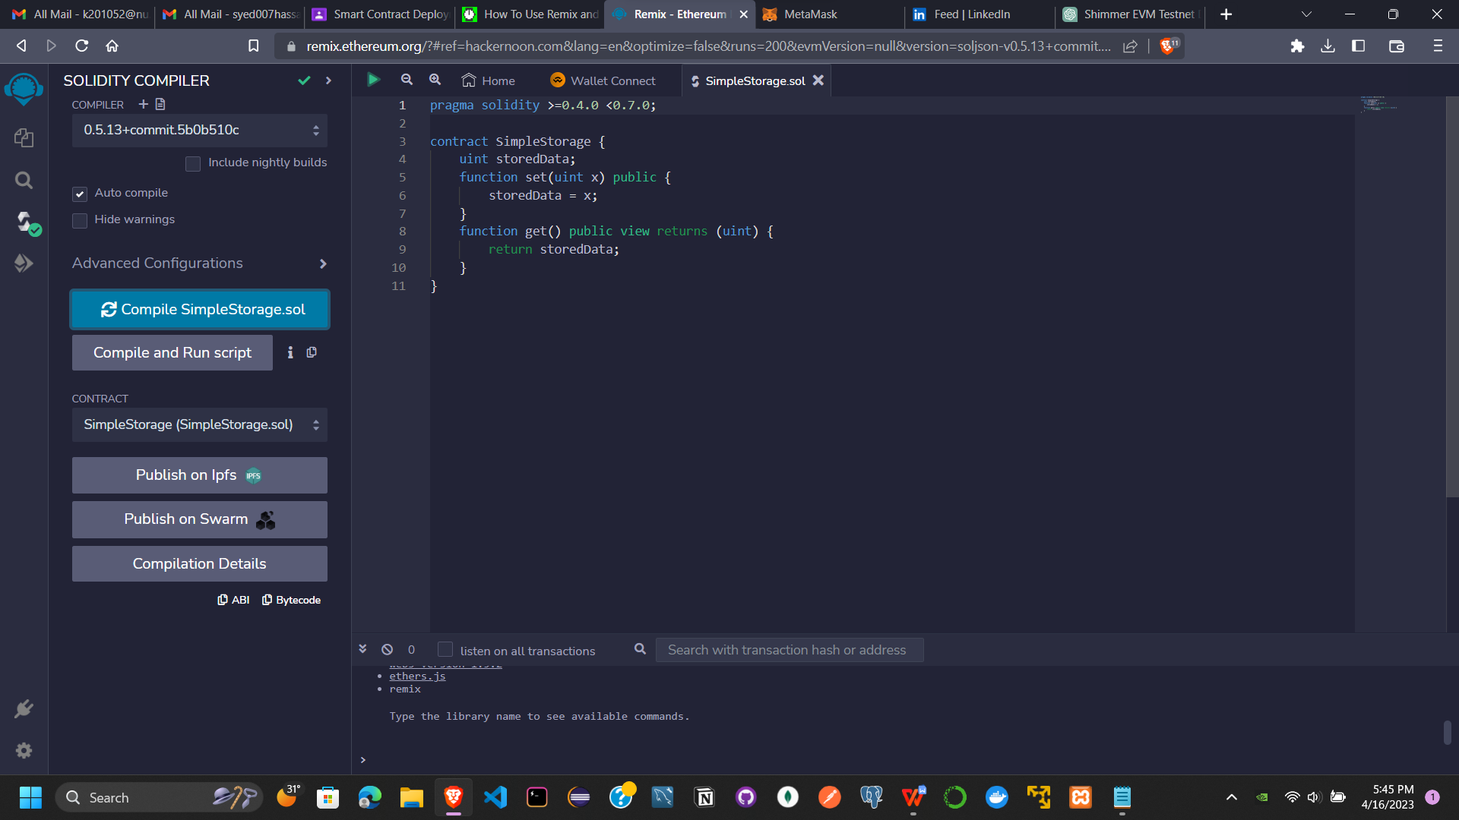

1. Compile and then deploy the smart contact.

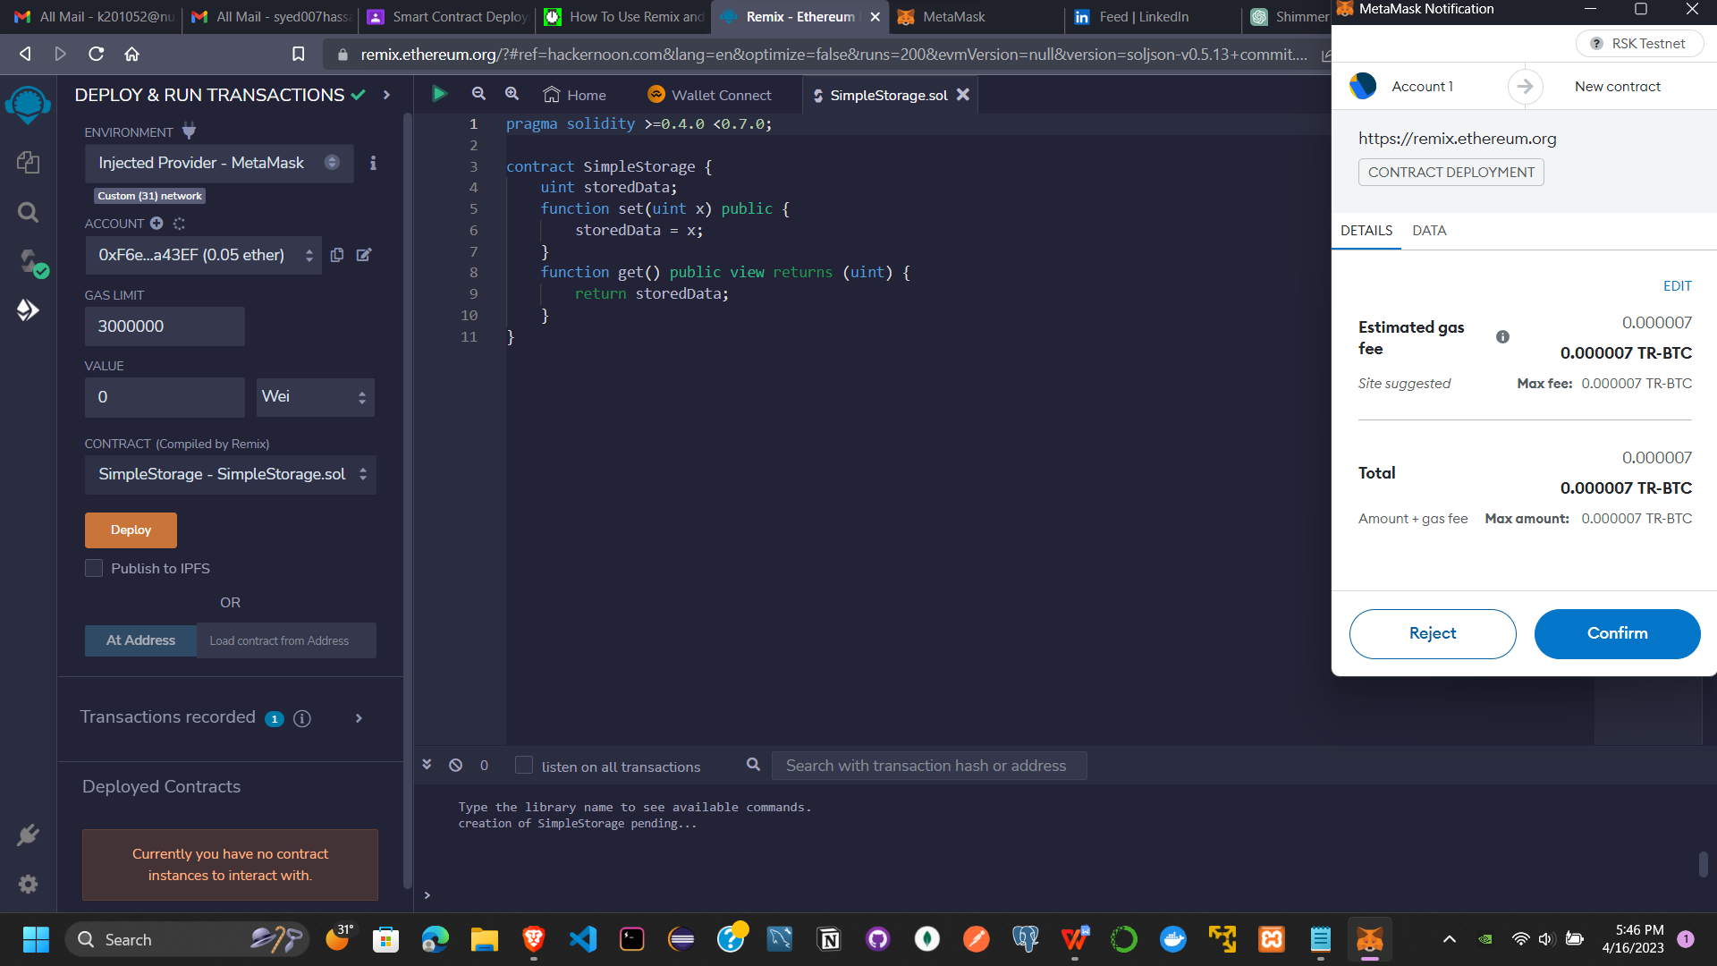

1. The trasaction is confirmed.

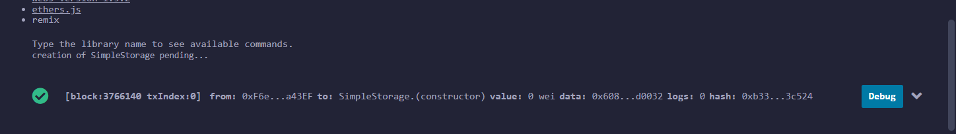

1. View the Transaction from your MetaMask wallet

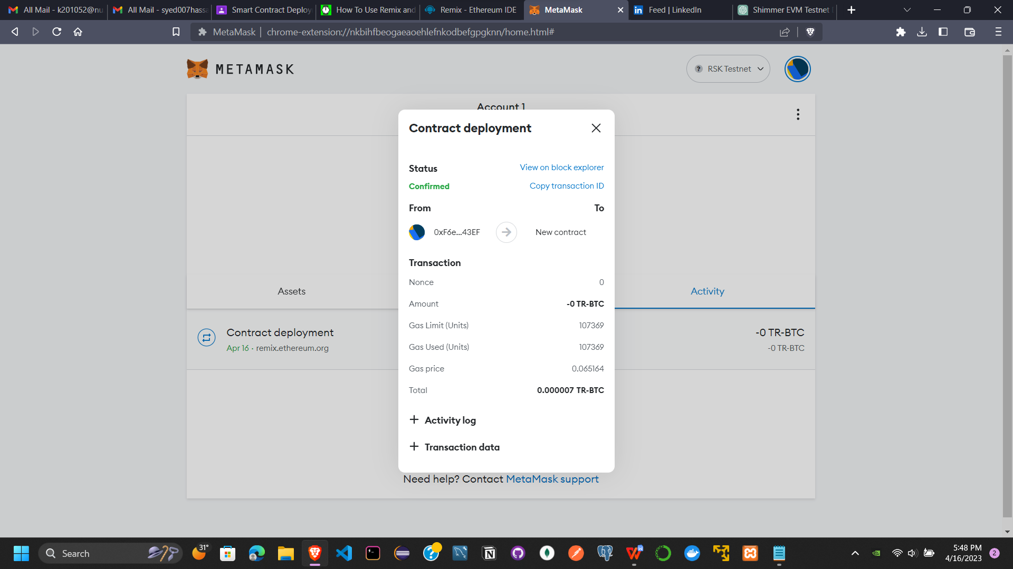

1. Now we have now set the transaction.

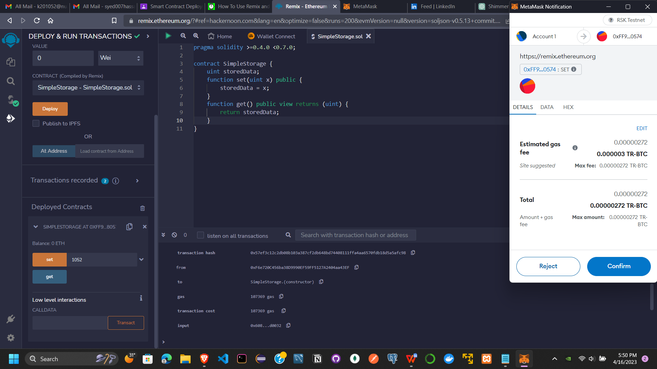

1. We have successfully set and get the transaction.

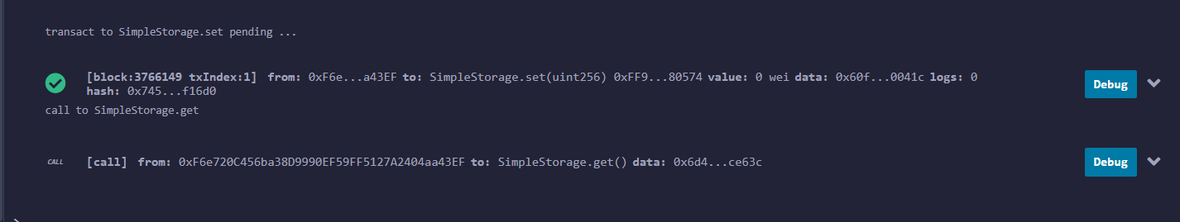

1. View the Activity at MetaMask.

